**LAB – 6**

**Aim : Write a code to perform bit stuffing.**

print("Ujjwal Varshney\n1901330100289\nCSE-V1-D")

msg = input("Enter the msg: ")

try:

idx = msg.index('11111')

newMsg = msg[:idx+5] + '0' + msg[idx+5:]

print("The msg after bit stuffing is:"+newMsg)

except:

print("The msg doesn't require bit stuffing.")

**OUTPUT:-**

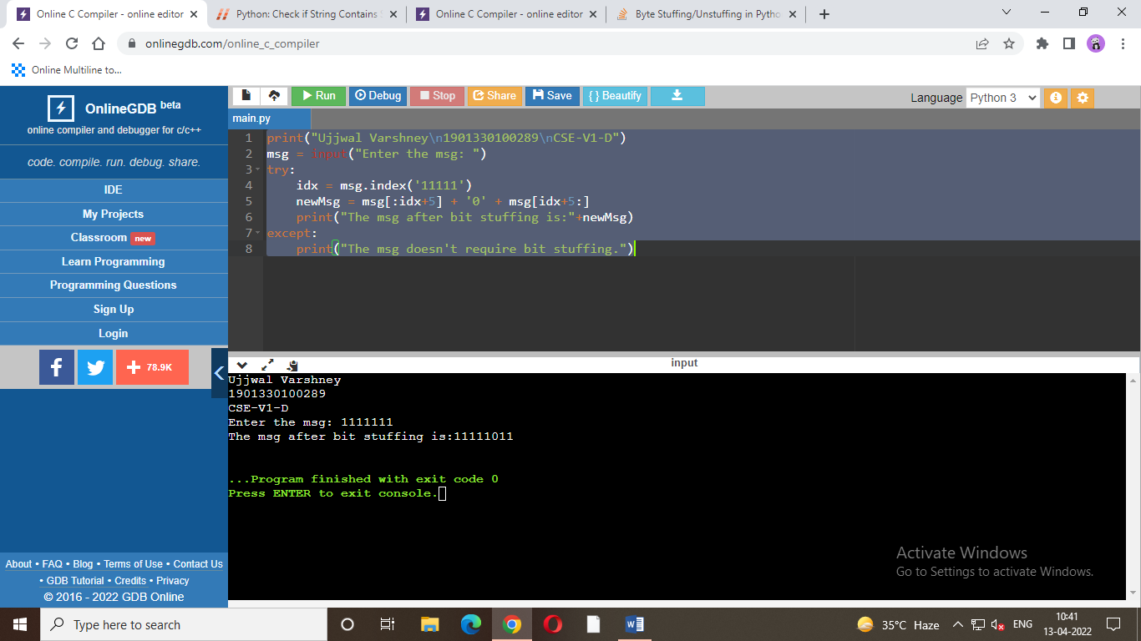

**Aim : Write a code to perform byte stuffing.**

print("Ujjwal Varshney\n1901330100289\nCSE-V1-D")

msg = input("Enter the msg: ")

flag = "flag"

esc = "esc"

x = msg.replace(esc,esc*2)

y = x.replace(flag, esc+flag)

print("msg after byte stuffing: "+y)

**OUTPUT:-**

